**STEP 4: CREATING CLASS DIAGRAM ASSOCIATIONS/ RELATIONSHIPS**

There are four main types of class diagram relationship:

1. Plain Association
2. Inheritance/generalisation
3. Aggregation
4. Composition

Create Class Diagram

Perform the steps below to create a UML class diagram in Visual Paradigm.

1. Select **Diagram > New** from the application toolbar.
2. In the **New Diagram** window, select**Class Diagram**.
3. Click **Next**.
4. Enter the diagram name and description. The **Location** field enables you to select a model to store the diagram.
5. Click **OK**.

Creating a Class

To create a class in a class diagram, click **Class** on the diagram toolbar and then click on the diagram

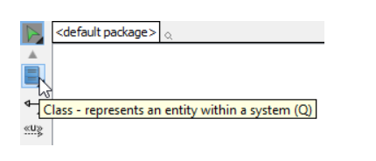

A class will be created.

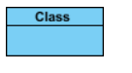

Creating attribute

To create attribute, right click the class and select **Add** > **Attribute** from the pop-up menu

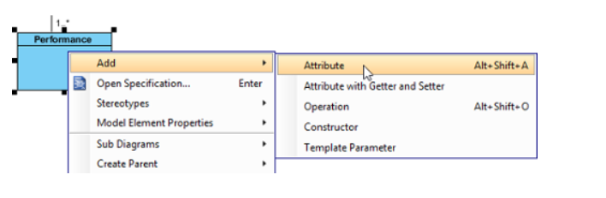

An attribute is created

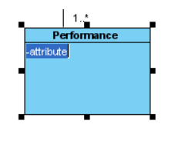

Creating attribute with enter key

After creating an attribute, press the **Enter**key, another attribute will be created. This method allows you to create multiple attributes quickly and easily.

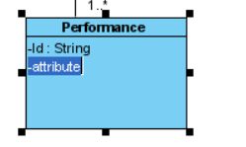

Creating operation

To create operation, right click the class and select **Add** > **Operation** from the pop-up menu.

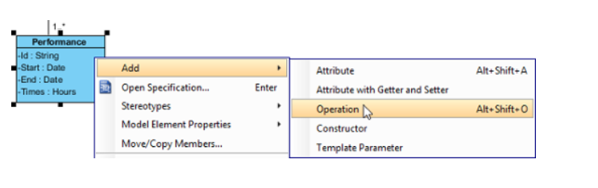

An operation is created

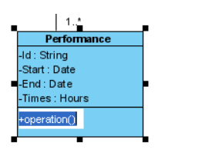

|  |
| --- |
| Operation created |

Similar to creating attribute, you can press the **Enter**key to create multiple operations continuously.

Creating association

To create an associated class in a class diagram:

1. Move your mouse pointer over the source shape.
2. Press on the **Resource Catalog** button and drag it out.  
   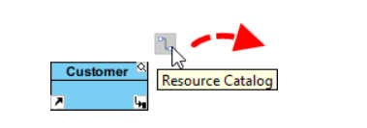
3. Release the mouse button at the place where you want the class to be created. If you want to connect to an existing class, drop at that class. Otherwise, drop in the empty space (either at the diagram background or container shape like package).
4. If you are connecting to an existing class, select **Association** from Resource Catalog.
5. If you are creating a new class, select **Association -> Class** from Resource Catalog.
6. If you want to create an aggregation or composition, select **Aggregation -> Class** or **Composition -> Class**instead.

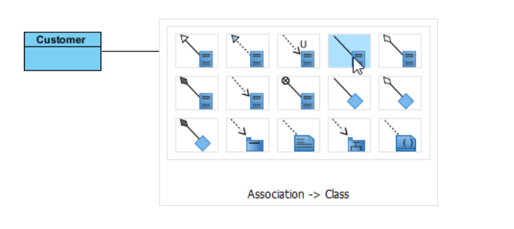

1. If you are creating a new class, you should see the class now and it is connected to the source shape. Enter its name and press **Enter** to confirm editing.  
   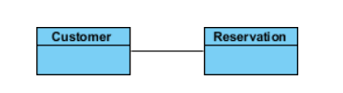

To edit multiplicity of an association end, right-click near the association end, select **Multiplicity** from the popup menu and then select a multiplicity.

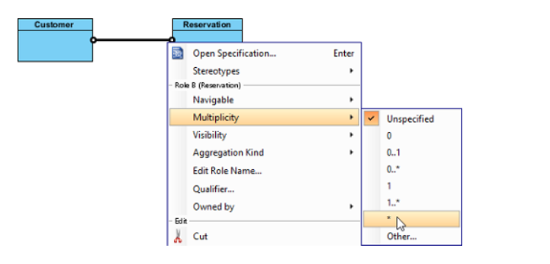

To show the direction of an association, right click on it and select **Presentation Options** > **Show Direction** from the pop-up menu.

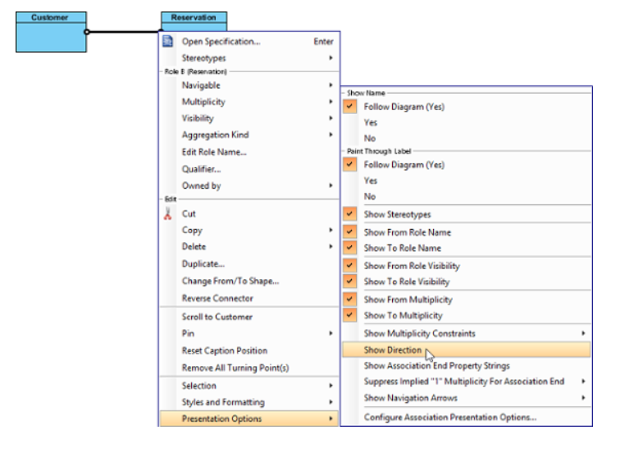

The direction arrow is shown beside the association.

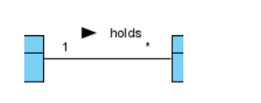

Creating generalization

To create a subclass:

1. Move your mouse pointer over the superclass.
2. Press on the **Resource Catalog** button and drag it out

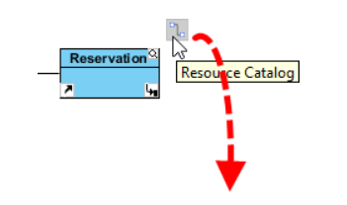

1. Release the mouse button at the place where you want the subclass to be created. If you want to connect to an existing class, drop at that class. Otherwise, drop an the empty space (either at the diagram background or container shape like package).
2. If you are connecting to an existing class, select **Generalization** from Resource Catalog. If you are creating a new class, select **Generalization -> Class** from Resource Catalog.

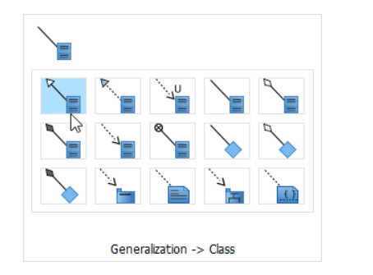

1. If you are creating a new class, you should see the class now and it is connected to the source shape with a generalization. Enter its name and press **Enter** to confirm editing

